Week 12 Lecture 1

Previous Lecture
- Lists by Linked Lists

Today’s Lecture
- Sorting Algorithms (1)
Sorting means . . .

- The values stored in an array have keys of a type for which the relational operators are defined. (We also assume unique keys.)

- Sorting rearranges the elements into either ascending or descending order within the array. (We’ll use ascending order.)

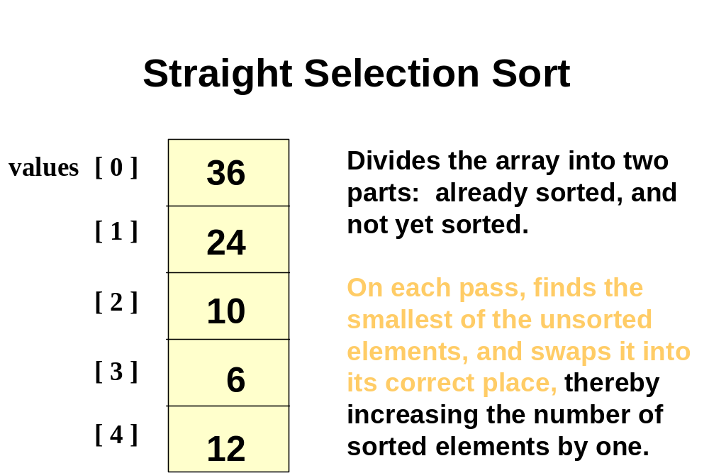
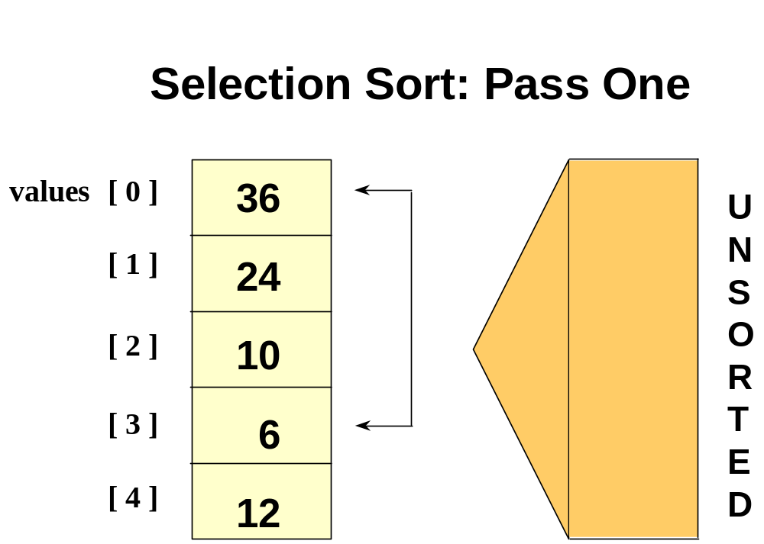
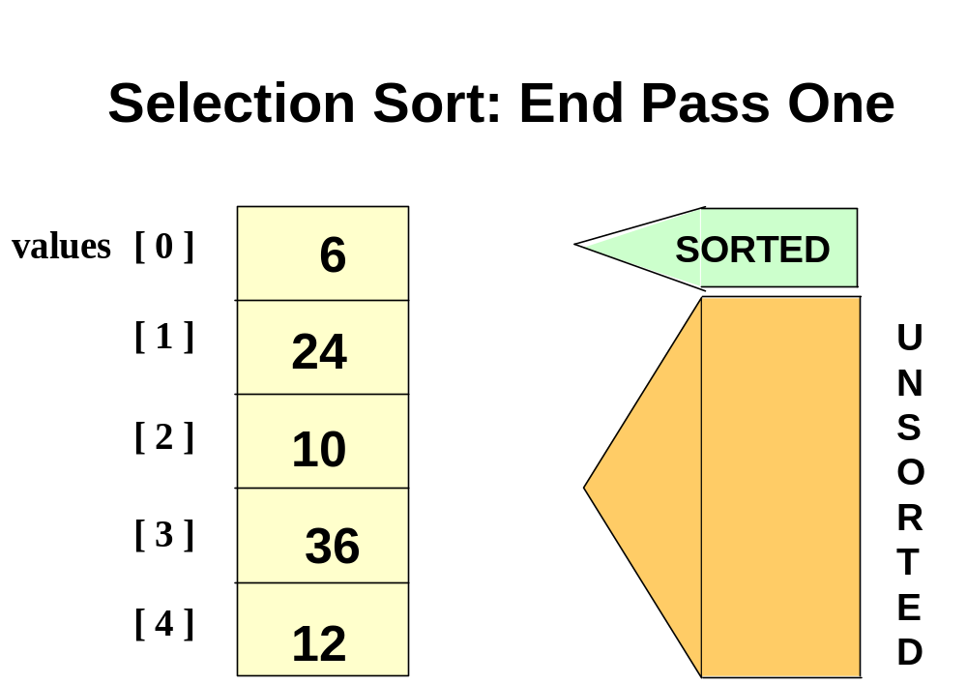
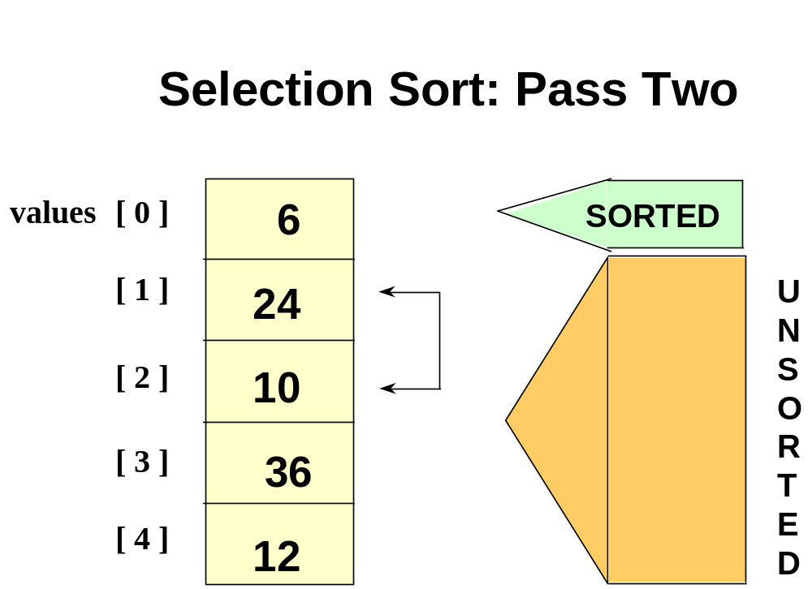
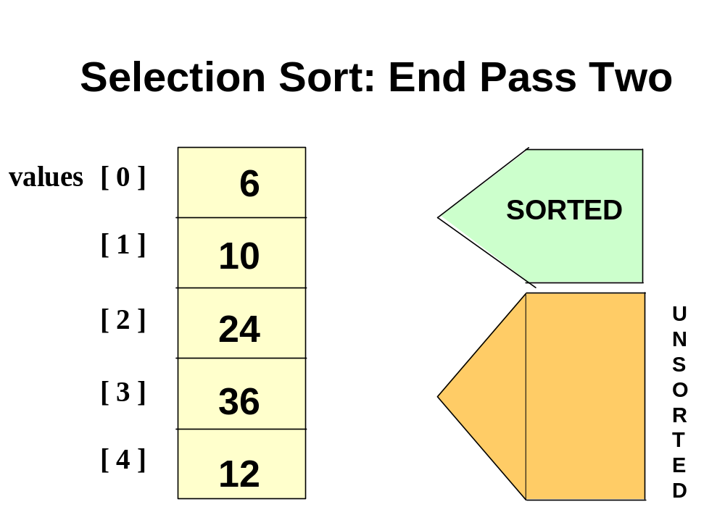

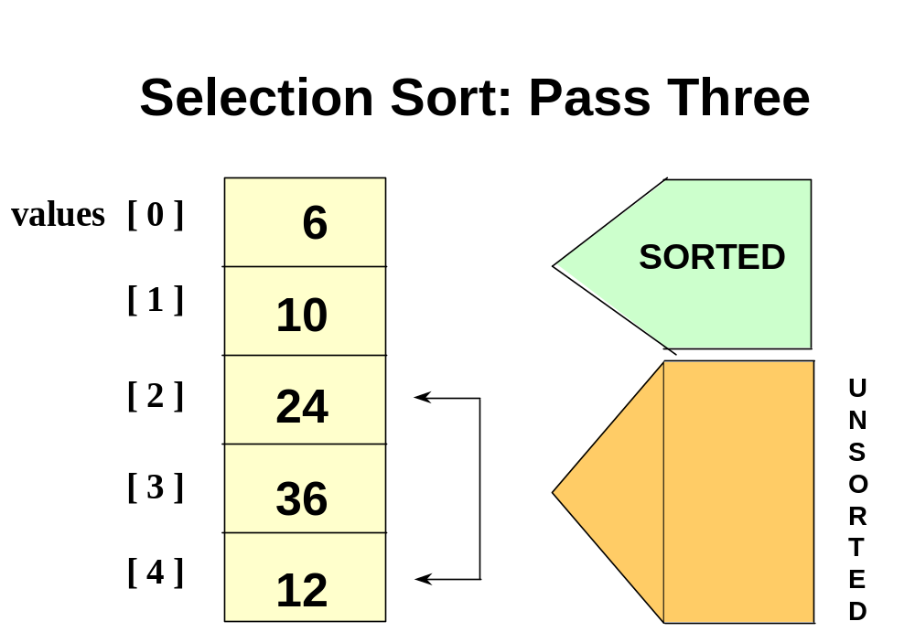
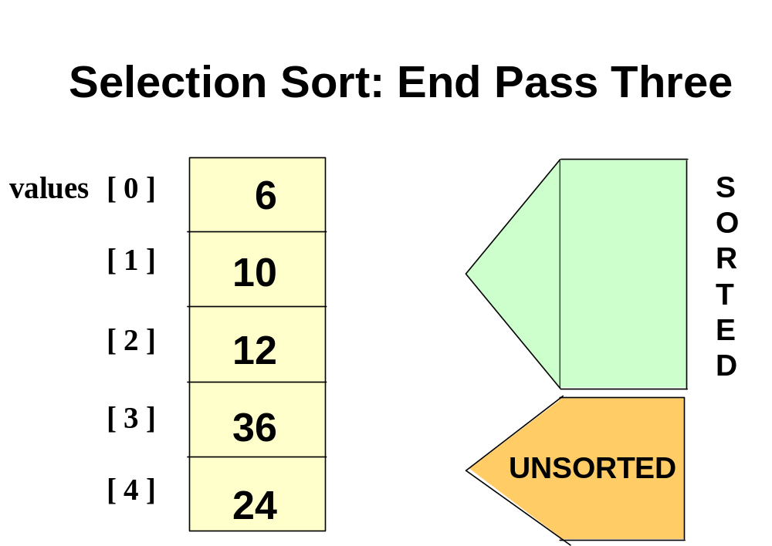
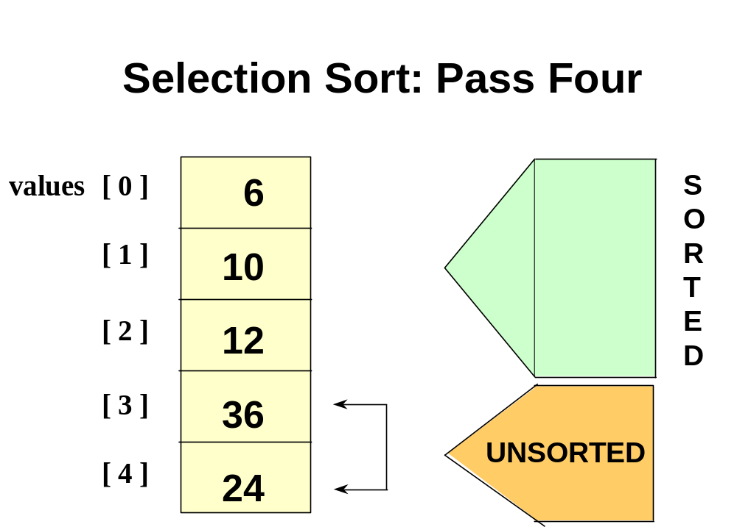
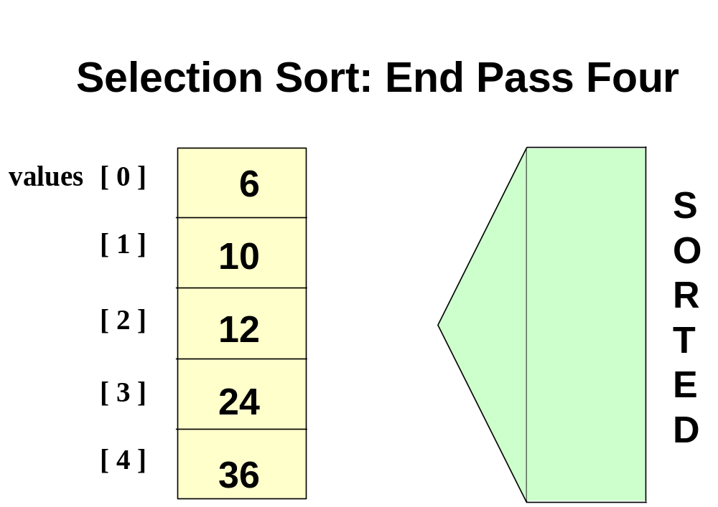
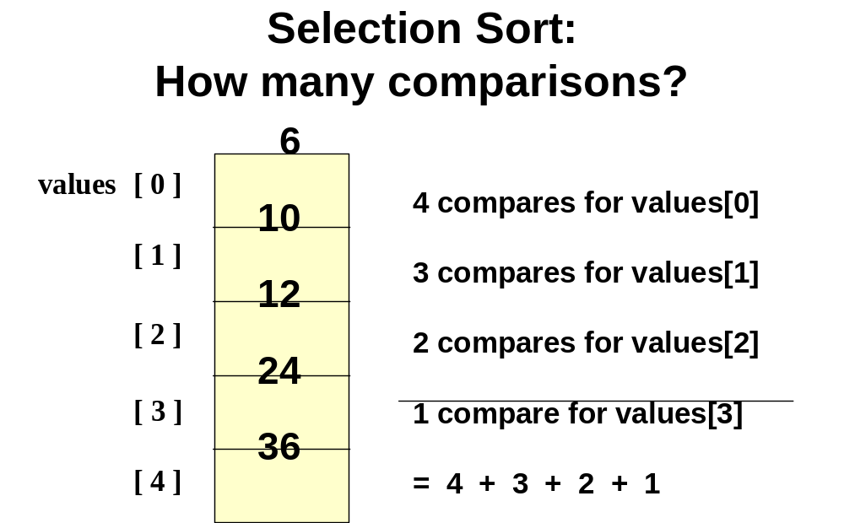

For selection sort in general

- The number of comparisons when the array contains N elements is

Sum = (N-1) + (N-2) + . . . + 2 + 1
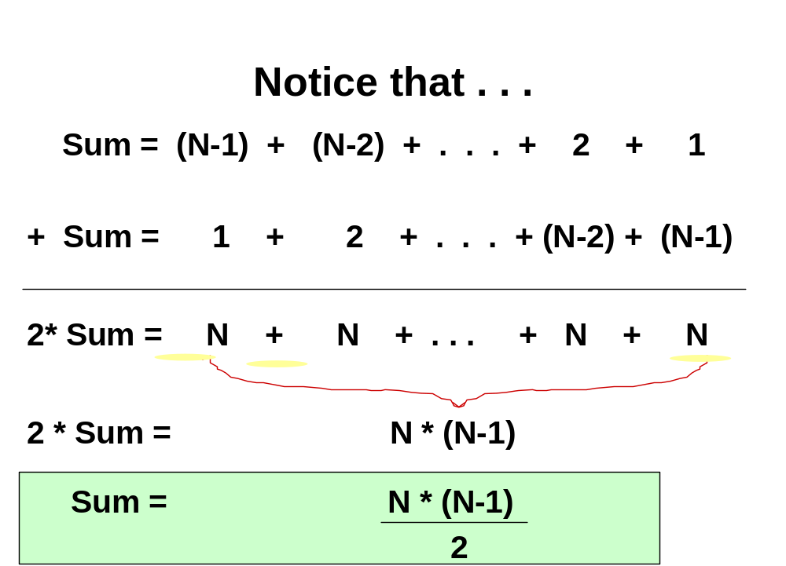

For selection sort in general

- The number of comparisons when the array contains N elements is

Sum = (N-1) + (N-2) + . . . + 2 + 1

Sum = N * (N-1) /2

Sum = .5 N² - .5 N

Sum = O(N²)
template <class ItemType >
int MinIndex ( ItemType values [ ] , int start , int end )

// Post: Function value = index of the smallest value in
// values [start] . . values [end].
{
int indexOfMin = start ;

for ( int index = start + 1 ; index <= end ; index++ )

if ( values [ index ] < values [ indexOfMin ] )

indexOfMin = index ;

return indexOfMin;

}
template <class ItemType >
void SelectionSort ( ItemType values [ ] , int numValues )

// Post: Sorts array values[0 . . numValues-1 ] into ascending
// order by key
{
int endIndex = numValues - 1 ;

for ( int current = 0 ; current < endIndex ; current++ )

Swap ( values [ current ] ,
values [ MinIndex ( values, current, endIndex ) ] ) ;

}
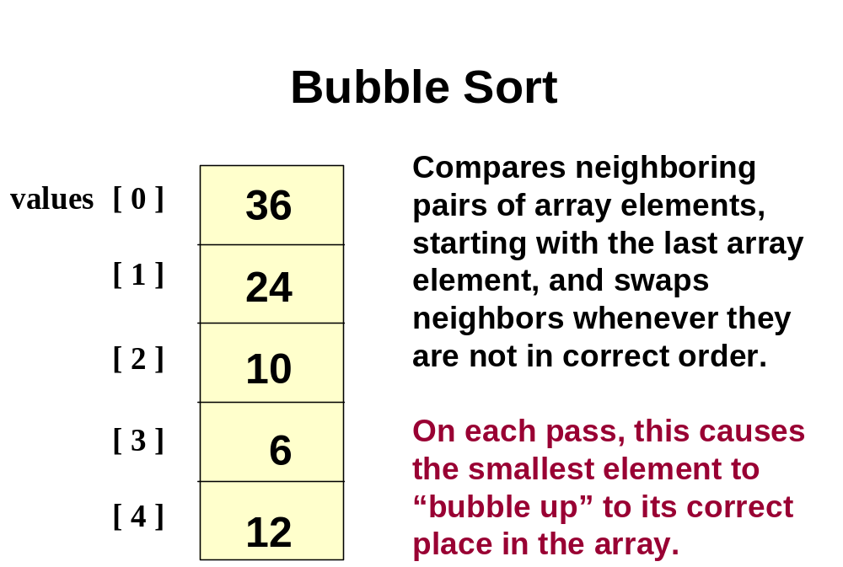
template <class ItemType >
void BubbleUp ( ItemType values [ ] , int start , int end )

// Post: Neighboring elements that were out of order have been
// swapped between values [start] and values [end],
// beginning at values [end].
{

for ( int index = end ; index > start ; index-- )

if (values [ index ] < values [ index - 1 ] )

Swap ( values [ index ], values [ index - 1 ] ) ;

}
template <class ItemType >
void BubbleSort ( ItemType values [ ] , int numValues )

// Post: Sorts array values[0 . . numValues-1 ] into ascending
// order by key
{
int current = 0 ;

while ( current < numValues - 1 )
{

BubbleUp ( values , current , numValues - 1 ) ;

current++ ;
}

}
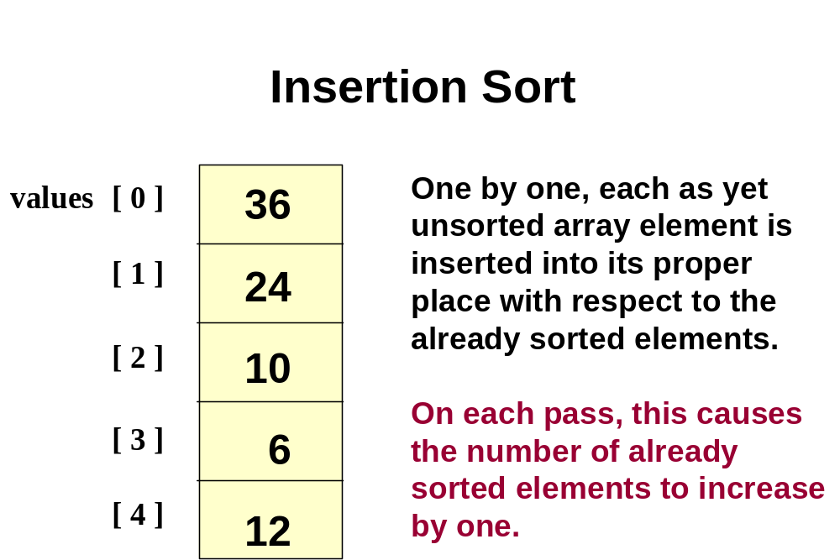
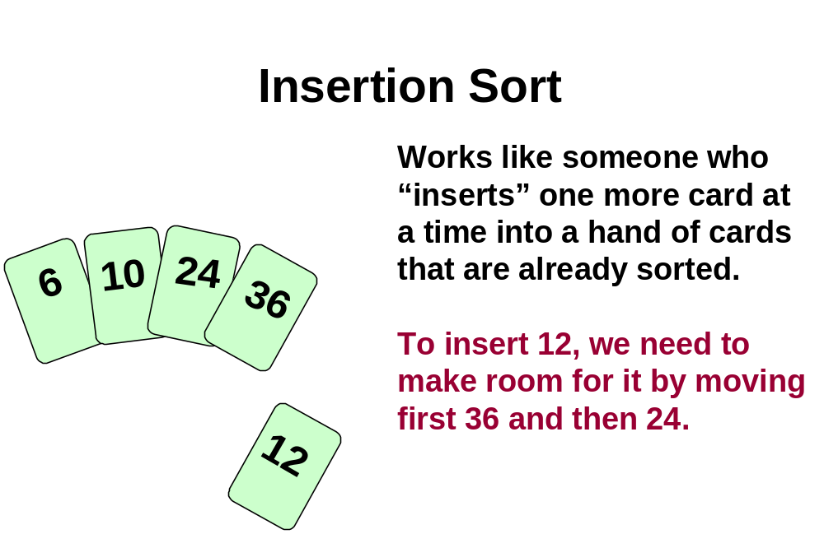
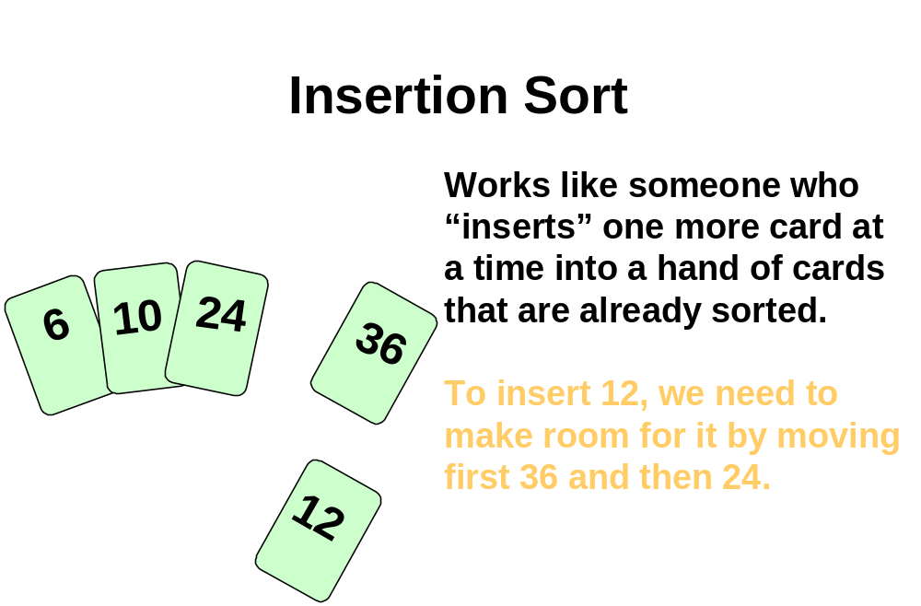
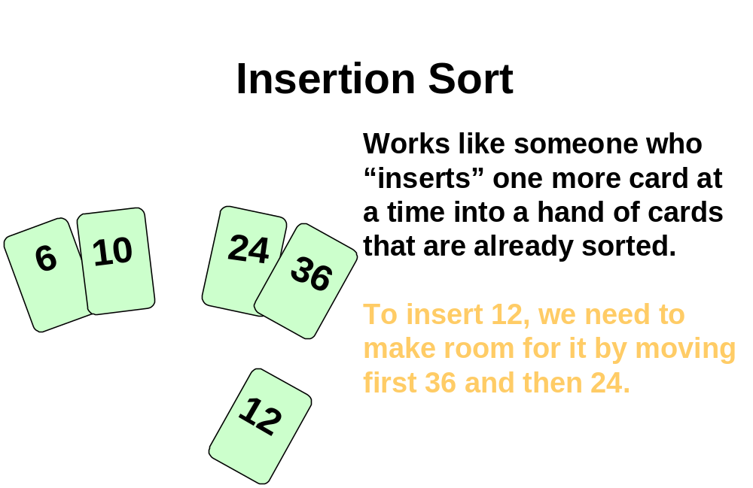
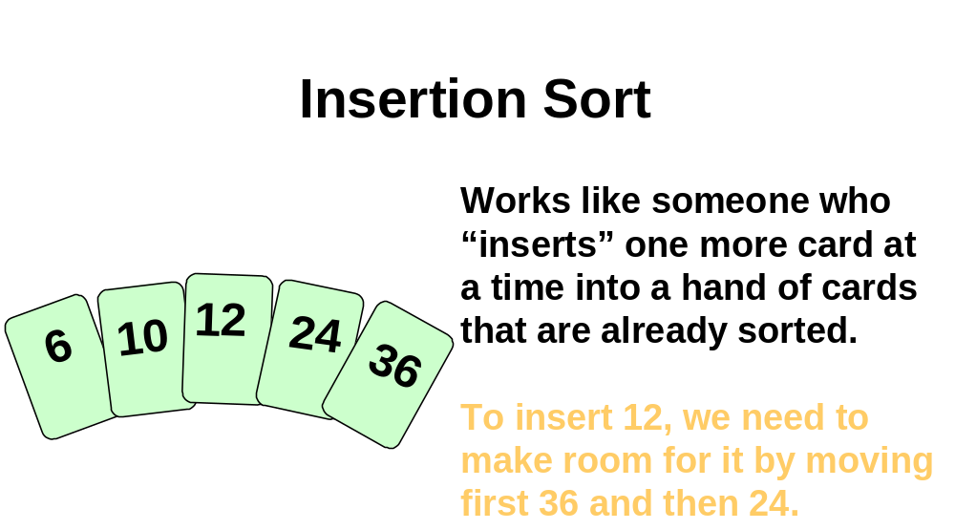
template <class ItemType >
void InsertItem ( ItemType values [ ] , int start , int end )

// Post: Elements between values [start] and values [end]
// have been sorted into ascending order by key.
{
bool finished = false ;
int current = end ;
bool moreToSearch = ( current != start ) ;

while ( moreToSearch && !finished )
{

if (values [ current ] < values [ current - 1 ] )
{
Swap ( values [ current ], values [ current - 1 ] ) ;
current-- ;
moreToSearch = ( current != start );
}
else
finished = true ;
}
}
template <class ItemType >
void InsertionSort ( ItemType values [ ] , int numValues )

// Post: Sorts array values[0 . . numValues-1 ] into ascending
// order by key
{
for ( int count = 0 ; count < numValues ; count++ )

InsertItem ( values , 0 , count ) ;

}
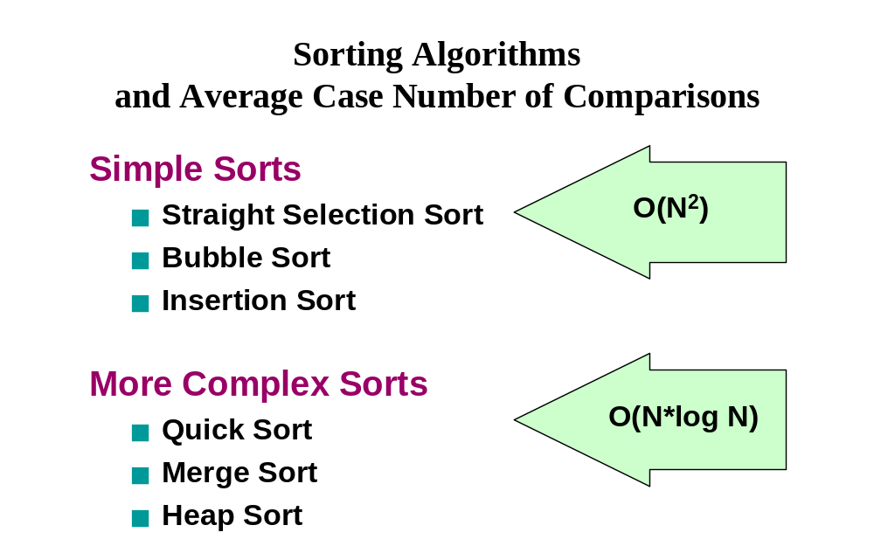

Today’s Lecture

- Sorting Algorithms (1)

Next Lecture

- Sorting Algorithms (2)

